Local Team Physiotherapy/Occupational Therapy Initial BPP Referral or Progress Report >3

Client Name: | Date of Assessment:
Address: | Therapists’ Emails:
DOB: | Therapists’ Mobiles:
Parents’/Guardians’ Emails | Parents’/Guardians’ Mobile:
Local Physiotherapist and Occupational Therapist: (name and address)

Diagnosis & Level of Brachial Plexus Palsy:

 | AMS | Toronto
Gravity Eliminated
No contraction | 0 | 0
Contraction, no mvt | 1 | 0.3
<1/2 range | 2 | 0.3
>1/2 range | 3 | 0.6
Full mvt | 4 | 0.6
Against Gravity
<1/2/ range | 5 | 0.6
>1/2 range | 6 | 1.3
Full mvt | 7 | 2

Active Range of Movement  (Observational) | AMS | Toronto  Score | PROM
Elbow Flexion
Elbow Extension
Wrist Extension
Thumb Extension
Finger Extension
Total Toronto Score |  | /10
Shoulder Abd
Shoulder Flexion
Shoulder Adduction
Shoulder External Rot @ midline
Shoulder Internal Rot @ midline
Pronation
Supination
Wrist Flexion
Finger Flexion
Thumb Flexion

Musculoskeletal Data:
Humeral Prominence | Anterior Posterior Mild Mod Severe
Spine Scoliosis-sitting | Yes No
Radial Head Dislocation | Yes No

Functional Independence Measure (FIM) SCORE
Put on a jumper |  | Fim Scale  7 Complete independence  6 Modified independence (requires an assistive device or more than reasonable time)  5 Supervision (standby cuing or coaxing, or setup of items  4 Minimum assistance (<25%)  3 Moderate assistance (25% - 50%)  2 Maximum assistance (50% - 75%)  1 Total assistance (>75%)  * not including top button  ** including shank  *** lift objects requiring two hands onto shelf above shoulder level
Take off a jumper
Tuck shirt in
Put socks on
Take coat off
Put trousers on
Take trousers off
Buttons own shirt *
Pulls up zip **
Washes hair completely
Puts hair up in bobbin |  | Comments:
Lifts object up with two hands ***
Uses knife and fork (>5 yrs only)

Treatment:
Frequency of Treatment, Treatment & Progress to date:
Present concerns that you would like addressed at this appointment/ clinical questions:
Signature: __________________________________ Date: ___________________________

This template report should be used when first referring a client to CRC. It may also be used as a progress report when a client is being reviewed. It is advisable to send the report well before expected appointment date.

Please complete as appropriate and do not hesitate to contact the CRC PT/OT Department if you have any queries.
Modified Mallet Score Sheet (include photos if consent given)

Client’s Name: File number:

Therapist’s Name: Date:
Client Name: DOB:
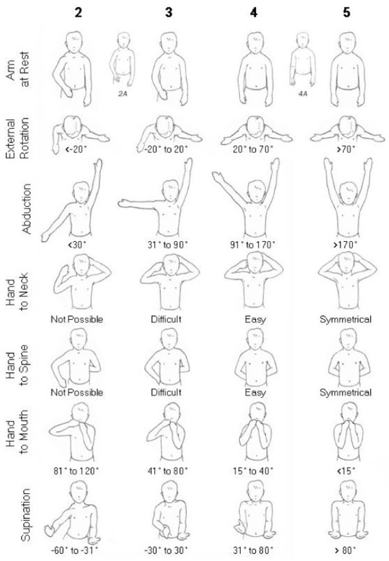
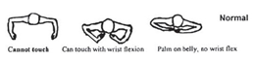
2

3

4

5

Score

Mallet

Internal
Rotation
*Note: Gr 1 = no function

Mallet Score: / 25 Modified Score: / 40

